LAPORAN PRAKTIKUM
PEMROGRAMAN WEB 2
MODUL 5



FUNCTION & DATABASE
Oleh:
ERISCHA MARSELA NIM. 2410817120022

PROGRAM STUDI TEKNOLOGI INFORMASI
FAKULTAS TEKNIK
UNIVERSITAS LAMBUNG MANGKURAT
MEI 2026

LEMBAR PENGESAHAN
LAPORAN PRAKTIKUM PEMROGRAMAN WEB 2
MODUL 4

Laporan Praktikum Pemrograman Web 2 Modul 5: FUNCTION & DATABASE ini disusun sebagai syarat lulus mata kuliah Praktikum Pemrograman Web II. Laporan Prakitkum ini dikerjakan oleh:

Nama Praktikan : ERISCHA MARSELA
NIM : 2410817120022

Menyetujui,  Asisten Praktikum  Ghani Mudzakir  NIM. 2310817110011 | Mengetahui,  Dosen Penanggung Jawab Praktikum  Ir. Muhammad Alkaff, S.Kom., M.Kom. Ph.D.  NIP. 19860613 201504 1 001

DAFTAR ISI

LEMBAR PENGESAHAN 2
DAFTAR ISI 3
DAFTAR GAMBAR 4
DAFTAR TABEL 5
SOAL 1 6
A. Source Code 7
B. Output Program 57
C. Pembahasan 60
Tautan Git 62

DAFTAR GAMBAR
Gambar 1. Soal nomor 1 6
Gambar 2. Dashboard Page 57
Gambar 3. Daftar Member Page 57
Gambar 4. Form Member Page 58
Gambar 5. Daftar Buku Page 58
Gambar 6. Form Buku Page 59
Gambar 7. Data Peminjaman Page 59
Gambar 8. Form Peminjaman Page 60

DAFTAR TABEL
Tabel 1. Contoh file yang harus ada 6
Tabel 2. Source Code Koneksi.php 7
Tabel 3. Source Code Model.php 7
Tabel 4. Source Code Index.php 13
Tabel 5.Source Code Member.php 16
Tabel 6. Source Code Buku.php 22
Tabel 7. Source Code Peminjaman.php 27
Tabel 8. Source Code FormMember.php 35
Tabel 9. Source Code FormBuku.php 41
Tabel 10. Source Code FormPeminjaman.php 46
Tabel 11. Source Code Database.sql (perpustakaan) 55

SOAL 1
Diberikan desain konseptual sebuah basis data seperti berikut :
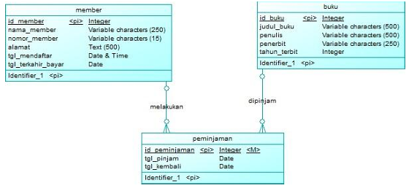
Gambar 1. Soal nomor 1
Buatlah sebuah aplikasi berbasis web sederhana yang dapat melakukan operasi CRUD (Create, Read, Update, Delete) dari hasil implementasi desain basis data yang diberikan. Adapun ketentuan pembuatannya sebagai berikut:
1. Koneksi database dibuat menjadi satu file sendiri yaitu Koneksi.php, kemudian gunakan fungsi require ketika ingin melakukan operasi ke basis data.
2. Operasi data seperti Insert, Update, Delete, Get Data dibuat menjadi fungsi sendiri masing- masing dan disimpan di dalam satu file khusus yaitu Model.php
3. Minimal terdapat file-file berikut di dalam projek
Tabel 1. Contoh file yang harus ada
NAMA FILE | KETERANGAN
Koneksi.php | Berisi fungsi-fungsi untuk melakukan koneksi ke basis data
Model.php | Berisi fungsi-fungsi untuk melakukan operasi data seperti insert, update, delete, get data untuk semua tabel
Member.php | Menampilkan semua data member dalam bentuk tabel dan terdapat tombol untuk melakukan tambah, edit, dan hapus data member.
Buku.php | Menampilkan semua data buku dalam bentuk tabel dan terdapat tombol untuk melakukan tambah, edit dan hapus data buku.
Peminjaman.php | Menampilkan semua data peminjaman dalam bentuk tabel dan terdapat tombol untuk melakukan tambah, edit, dan hapus data peminjaman.
FormMember.php | Menampilkan formulir isian untuk menambah atau mengubah data member.
FormBuku.php | Menampilkan formulir isian untuk menambah atau mengubah data buku.
FormPeminjaman.php | Menampilkan formulir isian untuk menambah atau mengubah data peminjaman.
Simpan dengan nama folder: PRAK501

Source Code
Tabel 2. Source Code Koneksi.php
<?php
define('DB_HOST', 'localhost');
define('DB_USER', 'root');
define('DB_PASS', '');
define('DB_NAME', 'perpustakaan');
function koneksiDatabase() {
$koneksi = mysqli_connect(DB_HOST, DB_USER, DB_PASS, DB_NAME);
if (!$koneksi) {
die("Koneksi gagal: " . mysqli_connect_error());
}
mysqli_set_charset($koneksi, 'utf8');
return $koneksi;
}
Tabel 3. Source Code Model.php
<?php
require_once 'Koneksi.php';
function getAllMember() {
$koneksi = koneksiDatabase();
$query = "SELECT * FROM member ORDER BY id_member ASC";
$result = mysqli_query($koneksi, $query);
$data = [];
while ($row = mysqli_fetch_assoc($result)) {
$data[] = $row;
}
mysqli_close($koneksi);
return $data;
}
function getMemberById($id_member) {
$koneksi = koneksiDatabase();
$id = mysqli_real_escape_string($koneksi, $id_member);
$query = "SELECT * FROM member WHERE id_member = '$id' LIMIT 1";
$result = mysqli_query($koneksi, $query);
$data = mysqli_fetch_assoc($result);
mysqli_close($koneksi);
return $data;
}
function insertMember($nama_member, $nomor_member, $alamat, $tgl_mendaftar, $tgl_terakhir_bayar) {
$koneksi = koneksiDatabase();
$nama_member = mysqli_real_escape_string($koneksi, $nama_member);
$nomor_member = mysqli_real_escape_string($koneksi, $nomor_member);
$alamat = mysqli_real_escape_string($koneksi, $alamat);
$tgl_mendaftar = mysqli_real_escape_string($koneksi, $tgl_mendaftar);
$tgl_terakhir_bayar = mysqli_real_escape_string($koneksi, $tgl_terakhir_bayar);
$tgl_bayar_val = ($tgl_terakhir_bayar !== '') ? "'$tgl_terakhir_bayar'" : "NULL";
$query = "INSERT INTO member (nama_member, nomor_member, alamat, tgl_mendaftar, tgl_terakhir_bayar)
VALUES ('$nama_member', '$nomor_member', '$alamat', '$tgl_mendaftar', $tgl_bayar_val)";
$result = mysqli_query($koneksi, $query);
mysqli_close($koneksi);
return $result;
}
function updateMember($id_member, $nama_member, $nomor_member, $alamat, $tgl_mendaftar, $tgl_terakhir_bayar) {
$koneksi = koneksiDatabase();
$id_member = mysqli_real_escape_string($koneksi, $id_member);
$nama_member = mysqli_real_escape_string($koneksi, $nama_member);
$nomor_member = mysqli_real_escape_string($koneksi, $nomor_member);
$alamat = mysqli_real_escape_string($koneksi, $alamat);
$tgl_mendaftar = mysqli_real_escape_string($koneksi, $tgl_mendaftar);
$tgl_terakhir_bayar = mysqli_real_escape_string($koneksi, $tgl_terakhir_bayar);
$tgl_bayar_val = ($tgl_terakhir_bayar !== '') ? "'$tgl_terakhir_bayar'" : "NULL";
$query = "UPDATE member
SET nama_member = '$nama_member',
nomor_member = '$nomor_member',
alamat = '$alamat',
tgl_mendaftar = '$tgl_mendaftar',
tgl_terakhir_bayar = $tgl_bayar_val
WHERE id_member = '$id_member'";
$result = mysqli_query($koneksi, $query);
mysqli_close($koneksi);
return $result;
}
function deleteMember($id_member) {
$koneksi = koneksiDatabase();
$id = mysqli_real_escape_string($koneksi, $id_member);
$query = "DELETE FROM member WHERE id_member = '$id'";
$result = mysqli_query($koneksi, $query);
mysqli_close($koneksi);
return $result;
}
function getAllBuku() {
$koneksi = koneksiDatabase();
$query = "SELECT * FROM buku ORDER BY id_buku ASC";
$result = mysqli_query($koneksi, $query);
$data = [];
while ($row = mysqli_fetch_assoc($result)) {
$data[] = $row;
}
mysqli_close($koneksi);
return $data;
}
function getBukuById($id_buku) {
$koneksi = koneksiDatabase();
$id = mysqli_real_escape_string($koneksi, $id_buku);
$query = "SELECT * FROM buku WHERE id_buku = '$id' LIMIT 1";
$result = mysqli_query($koneksi, $query);
$data = mysqli_fetch_assoc($result);
mysqli_close($koneksi);
return $data;
}
function insertBuku($judul_buku, $penulis, $penerbit, $tahun_terbit) {
$koneksi = koneksiDatabase();
$judul_buku = mysqli_real_escape_string($koneksi, $judul_buku);
$penulis = mysqli_real_escape_string($koneksi, $penulis);
$penerbit = mysqli_real_escape_string($koneksi, $penerbit);
$tahun_terbit = mysqli_real_escape_string($koneksi, $tahun_terbit);
$query = "INSERT INTO buku (judul_buku, penulis, penerbit, tahun_terbit)
VALUES ('$judul_buku', '$penulis', '$penerbit', '$tahun_terbit')";
$result = mysqli_query($koneksi, $query);
mysqli_close($koneksi);
return $result;
}
function updateBuku($id_buku, $judul_buku, $penulis, $penerbit, $tahun_terbit) {
$koneksi = koneksiDatabase();
$id_buku = mysqli_real_escape_string($koneksi, $id_buku);
$judul_buku = mysqli_real_escape_string($koneksi, $judul_buku);
$penulis = mysqli_real_escape_string($koneksi, $penulis);
$penerbit = mysqli_real_escape_string($koneksi, $penerbit);
$tahun_terbit = mysqli_real_escape_string($koneksi, $tahun_terbit);
$query = "UPDATE buku
SET judul_buku = '$judul_buku',
penulis = '$penulis',
penerbit = '$penerbit',
tahun_terbit = '$tahun_terbit'
WHERE id_buku = '$id_buku'";
$result = mysqli_query($koneksi, $query);
mysqli_close($koneksi);
return $result;
}
function deleteBuku($id_buku) {
$koneksi = koneksiDatabase();
$id = mysqli_real_escape_string($koneksi, $id_buku);
$query = "DELETE FROM buku WHERE id_buku = '$id'";
$result = mysqli_query($koneksi, $query);
mysqli_close($koneksi);
return $result;
}
function getAllPeminjaman() {
$koneksi = koneksiDatabase();
$query = "SELECT p.*, m.nama_member, m.nomor_member, b.judul_buku
FROM peminjaman p
JOIN member m ON p.id_member = m.id_member
JOIN buku b ON p.id_buku = b.id_buku
ORDER BY p.id_peminjaman ASC";
$result = mysqli_query($koneksi, $query);
$data = [];
while ($row = mysqli_fetch_assoc($result)) {
$data[] = $row;
}
mysqli_close($koneksi);
return $data;
}
function getPeminjamanById($id_peminjaman) {
$koneksi = koneksiDatabase();
$id = mysqli_real_escape_string($koneksi, $id_peminjaman);
$query = "SELECT p.*, m.nama_member, b.judul_buku
FROM peminjaman p
JOIN member m ON p.id_member = m.id_member
JOIN buku b ON p.id_buku = b.id_buku
WHERE p.id_peminjaman = '$id'
LIMIT 1";
$result = mysqli_query($koneksi, $query);
$data = mysqli_fetch_assoc($result);
mysqli_close($koneksi);
return $data;
}
function insertPeminjaman($id_member, $id_buku, $tgl_pinjam, $tgl_kembali) {
$koneksi = koneksiDatabase();
$id_member = mysqli_real_escape_string($koneksi, $id_member);
$id_buku = mysqli_real_escape_string($koneksi, $id_buku);
$tgl_pinjam = mysqli_real_escape_string($koneksi, $tgl_pinjam);
$tgl_kembali = mysqli_real_escape_string($koneksi, $tgl_kembali);
$query = "INSERT INTO peminjaman (id_member, id_buku, tgl_pinjam, tgl_kembali)
VALUES ('$id_member', '$id_buku', '$tgl_pinjam', '$tgl_kembali')";
$result = mysqli_query($koneksi, $query);
mysqli_close($koneksi);
return $result;
}
function updatePeminjaman($id_peminjaman, $id_member, $id_buku, $tgl_pinjam, $tgl_kembali) {
$koneksi = koneksiDatabase();
$id_peminjaman = mysqli_real_escape_string($koneksi, $id_peminjaman);
$id_member = mysqli_real_escape_string($koneksi, $id_member);
$id_buku = mysqli_real_escape_string($koneksi, $id_buku);
$tgl_pinjam = mysqli_real_escape_string($koneksi, $tgl_pinjam);
$tgl_kembali = mysqli_real_escape_string($koneksi, $tgl_kembali);
$query = "UPDATE peminjaman
SET id_member = '$id_member',
id_buku = '$id_buku',
tgl_pinjam = '$tgl_pinjam',
tgl_kembali = '$tgl_kembali'
WHERE id_peminjaman = '$id_peminjaman'";
$result = mysqli_query($koneksi, $query);
mysqli_close($koneksi);
return $result;
}
function deletePeminjaman($id_peminjaman) {
$koneksi = koneksiDatabase();
$id = mysqli_real_escape_string($koneksi, $id_peminjaman);
$query = "DELETE FROM peminjaman WHERE id_peminjaman = '$id'";
$result = mysqli_query($koneksi, $query);
mysqli_close($koneksi);
return $result;
}
function selesaikanPeminjaman($id_peminjaman) {
$koneksi = koneksiDatabase();
$id = mysqli_real_escape_string($koneksi, $id_peminjaman);
$tgl_selesai = date('Y-m-d');
$query = "UPDATE peminjaman
SET status = 'selesai',
tgl_kembali = '$tgl_selesai'
WHERE id_peminjaman = '$id' AND status = 'aktif'";
$result = mysqli_query($koneksi, $query);
mysqli_close($koneksi);
return $result;
}
Tabel 4. Source Code Index.php
<!DOCTYPE html>
<html lang="id">
<head>
<meta charset="UTF-8">
<meta name="viewport" content="width=device-width, initial-scale=1.0">
<title>Perpustakaan Digital</title>
<link href="https://fonts.googleapis.com/css2?family=Playfair+Display:wght@700&family=DM+Sans:wght@400;500;600&display=swap" rel="stylesheet">
<style>
:root {
--cream: #F5F0E8;
--brown: #3D2B1F;
--gold: #C8960C;
--rust: #A63D2F;
--sage: #4A6741;
--shadow: rgba(61,43,31,0.18);
}
* { margin: 0; padding: 0; box-sizing: border-box; }
body {
min-height: 100vh;
background: var(--cream);
font-family: 'DM Sans', sans-serif;
display: flex;
align-items: center;
justify-content: center;
position: relative;
overflow: hidden;
}
body::before {
content: '';
position: fixed;
top: 0; left: 0;
width: 100%; height: 100%;
background: url("https://img.freepik.com/premium-photo/too-many-books-library-library-inside-modern-library-interior-inside_179935-62265.jpg") center/cover no-repeat;
pointer-events: none;
}
.card {
background: #fff;
border-radius: 20px;
padding: 56px 64px;
box-shadow: 0 24px 64px var(--shadow);
max-width: 520px;
width: 90%;
text-align: center;
position: relative;
border-top: 6px solid var(--brown);
}
.card::before {
content: '';
position: absolute;
top: -6px; left: 50%;
transform: translateX(-50%);
width: 80px; height: 6px;
background: var(--gold);
border-radius: 0 0 4px 4px;
}
.logo {
font-size: 56px;
margin-bottom: 16px;
display: block;
}
h1 {
font-family: 'Playfair Display', serif;
font-size: 2rem;
color: var(--brown);
line-height: 1.2;
margin-bottom: 8px;
}
.subtitle {
color: #888;
font-size: 0.9rem;
margin-bottom: 40px;
letter-spacing: 0.04em;
}
.divider {
width: 48px;
height: 3px;
background: var(--gold);
margin: 0 auto 40px;
border-radius: 2px;
}
.menu-list {
display: flex;
flex-direction: column;
gap: 14px;
}
.menu-btn {
display: block;
text-decoration: none;
padding: 16px 24px;
border-radius: 12px;
font-weight: 600;
font-size: 1rem;
letter-spacing: 0.03em;
transition: all 0.22s ease;
position: relative;
overflow: hidden;
}
.menu-btn::after {
content: '→';
position: absolute;
right: 20px;
top: 50%;
transform: translateY(-50%) translateX(6px);
opacity: 0;
transition: all 0.22s ease;
}
.menu-btn:hover::after {
opacity: 1;
transform: translateY(-50%) translateX(0);
}
.btn-member {
background: var(--brown);
color: #fff;
}
.btn-member:hover { background: #5a3d2b; transform: translateY(-2px); box-shadow: 0 8px 24px var(--shadow); }
.btn-buku {
background: var(--sage);
color: #fff;
}
.btn-buku:hover { background: #3a5432; transform: translateY(-2px); box-shadow: 0 8px 24px rgba(74,103,65,0.3); }
.btn-peminjaman {
background: var(--rust);
color: #fff;
}
.btn-peminjaman:hover { background: #8a3225; transform: translateY(-2px); box-shadow: 0 8px 24px rgba(166,61,47,0.3); }
.footer-text {
margin-top: 36px;
font-size: 0.78rem;
color: #bbb;
letter-spacing: 0.06em;
text-transform: uppercase;
}
</style>
</head>
<body>
<div class="card">
<span class="logo">📚</span>
<h1>Perpustakaan Digital</h1>
<p class="subtitle">Sistem Informasi Manajemen Perpustakaan</p>
<div class="divider"></div>
<nav class="menu-list">
<a href="Member.php" class="menu-btn btn-member">Data Member</a>
<a href="Buku.php" class="menu-btn btn-buku">Data Buku</a>
<a href="Peminjaman.php" class="menu-btn btn-peminjaman">Data Peminjaman</a>
</nav>
<p class="footer-text">Erischa Marsela &mdash; Modul 5</p>
</div>
</body>
</html>
Tabel 5.Source Code Member.php
<?php
require_once 'Model.php';
if (isset($_GET['hapus'])) {
$id = $_GET['hapus'];
deleteMember($id);
header("Location: Member.php?pesan=hapus_berhasil");
exit;
}
$members = getAllMember();
$pesan = $_GET['pesan'] ?? '';
?>
<!DOCTYPE html>
<html lang="id">
<head>
<meta charset="UTF-8">
<meta name="viewport" content="width=device-width, initial-scale=1.0">
<title>Data Member – Perpustakaan</title>
<link href="https://fonts.googleapis.com/css2?family=Playfair+Display:wght@700&family=DM+Sans:wght@400;500;600&display=swap" rel="stylesheet">
<style>
:root {
--cream: #F5F0E8;
--brown: #3D2B1F;
--gold: #C8960C;
--rust: #A63D2F;
--sage: #4A6741;
--light: #FAF8F4;
}
* { margin: 0; padding: 0; box-sizing: border-box; }
body {
min-height: 100vh;
background: var(--cream);
font-family: 'DM Sans', sans-serif;
display: flex;
}
.sidebar {
width: 15%;
min-width: 250px;
min-height: 100vh;
background: var(--brown);
padding: 40px 24px;
display: flex;
flex-direction: column;
gap: 10px;
flex-shrink: 0;
box-shadow: 4px 0 24px rgba(61,43,31,0.05);
}
.sidebar h2 {
font-family: 'Playfair Display', serif;
color: #fff;
font-size: 1.3rem;
margin-bottom: 8px;
padding-bottom: 20px;
border-bottom: 1px solid rgba(255,255,255,0.15);
}
.sidebar a {
display: block;
padding: 12px 16px;
color: rgba(255,255,255,0.75);
text-decoration: none;
border-radius: 10px;
font-size: 0.95rem;
font-weight: 500;
transition: all 0.2s ease;
}
.sidebar a:hover, .sidebar a.active {
background: rgba(255,255,255,0.1);
color: #fff;
transform: translateX(4px);
}
.sidebar a.tambah {
background: var(--gold);
color: var(--brown);
font-weight: 600;
margin-top: 12px;
text-align: center;
}
.sidebar a.tambah:hover {
opacity: 0.9;
transform: translateY(-2px);
}
.main {
flex: 1;
padding: 48px 56px;
}
.page-header {
display: flex;
align-items: center;
justify-content: space-between;
margin-bottom: 36px;
}
.page-title {
font-family: 'Playfair Display', serif;
font-size: 2rem;
color: var(--brown);
}
.alert {
padding: 14px 24px;
border-radius: 12px;
margin-bottom: 28px;
font-weight: 500;
font-size: 0.92rem;
}
.alert-success { background: #d1fae5; color: #065f46; border-left: 4px solid #10b981; }
.alert-error { background: #fee2e2; color: #991b1b; border-left: 4px solid #ef4444; }
.table-wrap {
background: #fff;
border-radius: 18px;
overflow: hidden;
box-shadow: 0 8px 32px rgba(61,43,31,0.08);
}
table {
width: 100%;
border-collapse: collapse;
}
thead tr {
background: var(--brown);
color: #fff;
}
thead th {
padding: 18px 20px;
text-align: left;
font-size: 0.85rem;
font-weight: 600;
letter-spacing: 0.05em;
text-transform: uppercase;
}
tbody tr {
border-bottom: 1px solid #f2ede4;
transition: background 0.15s;
}
tbody tr:hover { background: var(--light); }
tbody td {
padding: 16px 20px;
font-size: 0.92rem;
color: #444;
vertical-align: middle;
}
.badge {
display: inline-block;
padding: 4px 12px;
border-radius: 20px;
font-size: 0.8rem;
font-weight: 600;
background: #ede8df;
color: var(--brown);
}
.actions {
display: flex;
gap: 8px;
align-items: center;
}
.btn {
display: inline-block;
padding: 8px 16px;
border-radius: 8px;
font-size: 0.85rem;
font-weight: 600;
text-decoration: none;
border: none;
cursor: pointer;
transition: all 0.18s ease;
}
.btn-hapus { background: var(--rust); color: #fff; }
.btn-hapus:hover { opacity: 0.9; transform: translateY(-1px); }
.btn-ubah { background: var(--gold); color: var(--brown); }
.btn-ubah:hover { opacity: 0.9; transform: translateY(-1px); }
.empty-state {
text-align: center;
padding: 56px;
color: #aaa;
font-size: 1rem;
}
</style>
</head>
<body>
<aside class="sidebar">
<h2>📚 Perpustakaan</h2>
<a href="Index.php">🏠 Beranda</a>
<a href="Member.php" class="active">👤 Member</a>
<a href="Buku.php">📖 Buku</a>
<a href="Peminjaman.php">🔖 Peminjaman</a>
<a href="FormMember.php" class="tambah">+ Tambah Member</a>
</aside>
<main class="main">
<div class="page-header">
<h1 class="page-title">Daftar Member</h1>
</div>
<?php if ($pesan === 'hapus_berhasil'): ?>
<div class="alert alert-success">✅ Data member berhasil dihapus.</div>
<?php elseif ($pesan === 'simpan_berhasil'): ?>
<div class="alert alert-success">✅ Data member berhasil disimpan.</div>
<?php elseif ($pesan === 'ubah_berhasil'): ?>
<div class="alert alert-success">✅ Data member berhasil diperbarui.</div>
<?php endif; ?>
<div class="table-wrap">
<table>
<thead>
<tr>
<th>ID</th>
<th>Nama Member</th>
<th>No. Member</th>
<th>Alamat</th>
<th>Tgl Mendaftar</th>
<th>Tgl Terakhir Bayar</th>
<th>Opsi</th>
</tr>
</thead>
<tbody>
<?php if (empty($members)): ?>
<tr><td colspan="7" class="empty-state">Belum ada data member.</td></tr>
<?php else: ?>
<?php foreach ($members as $m): ?>
<tr>
<td><span class="badge"><?= htmlspecialchars($m['id_member']) ?></span></td>
<td><strong><?= htmlspecialchars($m['nama_member']) ?></strong></td>
<td><?= htmlspecialchars($m['nomor_member']) ?></td>
<td><?= htmlspecialchars($m['alamat'] ?? '-') ?></td>
<td><?= htmlspecialchars($m['tgl_mendaftar'] ?? '-') ?></td>
<td><?= htmlspecialchars($m['tgl_terakhir_bayar'] ?? '-') ?></td>
<td style="display:flex;gap:6px;align-items:center;">
<a href="Member.php?hapus=<?= $m['id_member'] ?>"
class="btn btn-hapus"
onclick="return confirm('Yakin hapus member ini?')">Hapus</a>
<a href="FormMember.php?id=<?= $m['id_member'] ?>"
class="btn btn-ubah">Ubah</a>
</td>
</tr>
<?php endforeach; ?>
<?php endif; ?>
</tbody>
</table>
</div>
</main>
</body>
</html>
Tabel 6. Source Code Buku.php
<?php
require_once 'Model.php';
if (isset($_GET['hapus'])) {
$id = $_GET['hapus'];
deleteBuku($id);
header("Location: Buku.php?pesan=hapus_berhasil");
exit;
}
$bukus = getAllBuku();
$pesan = $_GET['pesan'] ?? '';
?>
<!DOCTYPE html>
<html lang="id">
<head>
<meta charset="UTF-8">
<meta name="viewport" content="width=device-width, initial-scale=1.0">
<title>Data Buku – Perpustakaan</title>
<link href="https://fonts.googleapis.com/css2?family=Playfair+Display:wght@700&family=DM+Sans:wght@400;500;600&display=swap" rel="stylesheet">
<style>
:root {
--cream: #F5F0E8;
--brown: #3D2B1F;
--gold: #C8960C;
--rust: #A63D2F;
--sage: #4A6741;
--light: #FAF8F4;
}
* { margin: 0; padding: 0; box-sizing: border-box; }
body {
min-height: 100vh;
background: var(--cream);
font-family: 'DM Sans', sans-serif;
display: flex;
}
.sidebar {
width: 15%;
min-width: 250px;
min-height: 100vh;
background: var(--brown);
padding: 40px 24px;
display: flex;
flex-direction: column;
gap: 10px;
flex-shrink: 0;
box-shadow: 4px 0 24px rgba(61,43,31,0.05);
}
.sidebar h2 {
font-family: 'Playfair Display', serif;
color: #fff;
font-size: 1.3rem;
margin-bottom: 8px;
padding-bottom: 20px;
border-bottom: 1px solid rgba(255,255,255,0.15);
}
.sidebar a {
display: block;
padding: 12px 16px;
color: rgba(255,255,255,0.75);
text-decoration: none;
border-radius: 10px;
font-size: 0.95rem;
font-weight: 500;
transition: all 0.2s ease;
}
.sidebar a:hover, .sidebar a.active {
background: rgba(255,255,255,0.1);
color: #fff;
transform: translateX(4px);
}
.sidebar a.tambah {
background: var(--gold);
color: var(--brown);
font-weight: 600;
margin-top: 12px;
text-align: center;
}
.sidebar a.tambah:hover {
opacity: 0.9;
transform: translateY(-2px);
}
.main {
flex: 1;
padding: 48px 56px;
}
.page-header {
display: flex;
align-items: center;
justify-content: space-between;
margin-bottom: 36px;
}
.page-title {
font-family: 'Playfair Display', serif;
font-size: 2rem;
color: var(--brown);
}
.alert {
padding: 14px 24px;
border-radius: 12px;
margin-bottom: 28px;
font-weight: 500;
font-size: 0.92rem;
}
.alert-success { background: #d1fae5; color: #065f46; border-left: 4px solid #10b981; }
.alert-error { background: #fee2e2; color: #991b1b; border-left: 4px solid #ef4444; }
.table-wrap {
background: #fff;
border-radius: 18px;
overflow: hidden;
box-shadow: 0 8px 32px rgba(61,43,31,0.08);
}
table {
width: 100%;
border-collapse: collapse;
}
thead tr {
background: var(--brown);
color: #fff;
}
thead th {
padding: 18px 20px;
text-align: left;
font-size: 0.85rem;
font-weight: 600;
letter-spacing: 0.05em;
text-transform: uppercase;
}
tbody tr {
border-bottom: 1px solid #f2ede4;
transition: background 0.15s;
}
tbody tr:hover { background: var(--light); }
tbody td {
padding: 16px 20px;
font-size: 0.92rem;
color: #444;
vertical-align: middle;
}
.badge {
display: inline-block;
padding: 4px 12px;
border-radius: 20px;
font-size: 0.8rem;
font-weight: 600;
background: #ede8df;
color: var(--brown);
}
.actions {
display: flex;
gap: 8px;
align-items: center;
}
.btn {
display: inline-block;
padding: 8px 16px;
border-radius: 8px;
font-size: 0.85rem;
font-weight: 600;
text-decoration: none;
border: none;
cursor: pointer;
transition: all 0.18s ease;
}
.btn-hapus { background: var(--rust); color: #fff; }
.btn-hapus:hover { opacity: 0.9; transform: translateY(-1px); }
.btn-ubah { background: var(--gold); color: var(--brown); }
.btn-ubah:hover { opacity: 0.9; transform: translateY(-1px); }
.empty-state {
text-align: center;
padding: 56px;
color: #aaa;
font-size: 1rem;
}
</style>
</head>
<body>
<aside class="sidebar">
<h2>📚 Perpustakaan</h2>
<a href="Index.php">🏠 Beranda</a>
<a href="Member.php">👤 Member</a>
<a href="Buku.php" class="active">📖 Buku</a>
<a href="Peminjaman.php">🔖 Peminjaman</a>
<a href="FormBuku.php" class="tambah">+ Tambah Buku</a>
</aside>
<main class="main">
<div class="page-header">
<h1 class="page-title">Daftar Buku</h1>
</div>
<?php if ($pesan === 'hapus_berhasil'): ?>
<div class="alert alert-success">✅ Data buku berhasil dihapus.</div>
<?php elseif ($pesan === 'simpan_berhasil'): ?>
<div class="alert alert-success">✅ Data buku berhasil disimpan.</div>
<?php elseif ($pesan === 'ubah_berhasil'): ?>
<div class="alert alert-success">✅ Data buku berhasil diperbarui.</div>
<?php endif; ?>
<div class="table-wrap">
<table>
<thead>
<tr>
<th>ID</th>
<th>Judul Buku</th>
<th>Penulis</th>
<th>Penerbit</th>
<th>Tahun Terbit</th>
<th>Opsi</th>
</tr>
</thead>
<tbody>
<?php if (empty($bukus)): ?>
<tr><td colspan="6" class="empty-state">Belum ada data buku.</td></tr>
<?php else: ?>
<?php foreach ($bukus as $b): ?>
<tr>
<td><span class="badge"><?= htmlspecialchars($b['id_buku']) ?></span></td>
<td><strong><?= htmlspecialchars($b['judul_buku']) ?></strong></td>
<td><?= htmlspecialchars($b['penulis']) ?></td>
<td><?= htmlspecialchars($b['penerbit'] ?? '-') ?></td>
<td><span class="badge badge-year"><?= htmlspecialchars($b['tahun_terbit'] ?? '-') ?></span></td>
<td style="display:flex;gap:6px;align-items:center;">
<a href="Buku.php?hapus=<?= $b['id_buku'] ?>"
class="btn btn-hapus"
onclick="return confirm('Yakin hapus buku ini?')">Hapus</a>
<a href="FormBuku.php?id=<?= $b['id_buku'] ?>"
class="btn btn-ubah">Ubah</a>
</td>
</tr>
<?php endforeach; ?>
<?php endif; ?>
</tbody>
</table>
</div>
</main>
</body>
</html>
Tabel 7. Source Code Peminjaman.php
<?php
require_once 'Model.php';
if (isset($_GET['hapus'])) {
$id = $_GET['hapus'];
deletePeminjaman($id);
header("Location: Peminjaman.php?pesan=hapus_berhasil");
exit;
}
if (isset($_GET['selesai'])) {
$id = $_GET['selesai'];
// Mengeksekusi fungsi baru Anda dan mengecek hasilnya
$eksekusi = selesaikanPeminjaman($id);
if ($eksekusi) {
header("Location: Peminjaman.php?pesan=selesai_berhasil");
} else {
header("Location: Peminjaman.php?pesan=selesai_gagal");
}
exit;
}
$peminjamans = getAllPeminjaman();
$pesan = $_GET['pesan'] ?? '';
function hitungStatus($row) {
if (($row['status'] ?? 'aktif') === 'selesai') return 'selesai';
$today = date('Y-m-d');
if ($today > $row['tgl_kembali']) return 'overdue';
if ($today === $row['tgl_kembali']) return 'today';
return 'aktif';
}
?>
<!DOCTYPE html>
<html lang="id">
<head>
<meta charset="UTF-8">
<meta name="viewport" content="width=device-width, initial-scale=1.0">
<title>Data Peminjaman – Perpustakaan</title>
<link href="https://fonts.googleapis.com/css2?family=Playfair+Display:wght@700&family=DM+Sans:wght@400;500;600&display=swap" rel="stylesheet">
<style>
:root {
--cream: #F5F0E8;
--brown: #3D2B1F;
--gold: #C8960C;
--rust: #A63D2F;
--sage: #4A6741;
--blue: #1e4d8c;
--light: #FAF8F4;
}
* { margin: 0; padding: 0; box-sizing: border-box; }
body {
min-height: 100vh;
background: var(--cream);
font-family: 'DM Sans', sans-serif;
display: flex;
}
.sidebar {
width: 15%;
min-width: 250px;
min-height: 100vh;
background: var(--brown);
padding: 40px 24px;
display: flex;
flex-direction: column;
gap: 10px;
flex-shrink: 0;
box-shadow: 4px 0 24px rgba(61,43,31,0.05);
}
.sidebar h2 {
font-family: 'Playfair Display', serif;
color: #fff;
font-size: 1.3rem;
margin-bottom: 8px;
padding-bottom: 20px;
border-bottom: 1px solid rgba(255,255,255,0.15);
}
.sidebar a {
display: block;
padding: 12px 16px;
color: rgba(255,255,255,0.75);
text-decoration: none;
border-radius: 10px;
font-size: 0.95rem;
font-weight: 500;
transition: all 0.2s ease;
}
.sidebar a:hover, .sidebar a.active {
background: rgba(255,255,255,0.1);
color: #fff;
transform: translateX(4px);
}
.sidebar a.tambah {
background: var(--gold);
color: var(--brown);
font-weight: 600;
margin-top: 12px;
text-align: center;
}
.sidebar a.tambah:hover {
opacity: 0.9;
transform: translateY(-2px);
}
.main {
flex: 1;
padding: 48px 56px;
}
.page-header {
display: flex;
align-items: center;
justify-content: space-between;
margin-bottom: 36px;
}
.page-title {
font-family: 'Playfair Display', serif;
font-size: 2rem;
color: var(--brown);
}
.alert {
padding: 14px 24px;
border-radius: 12px;
margin-bottom: 28px;
font-weight: 500;
font-size: 0.92rem;
}
.alert-success { background: #d1fae5; color: #065f46; border-left: 4px solid #10b981; }
.alert-error { background: #fee2e2; color: #991b1b; border-left: 4px solid #ef4444; }
.table-wrap {
background: #fff;
border-radius: 18px;
overflow: hidden;
box-shadow: 0 8px 32px rgba(61,43,31,0.08);
}
table {
width: 100%;
border-collapse: collapse;
}
thead tr {
background: var(--brown);
color: #fff;
}
thead th {
padding: 18px 20px;
text-align: left;
font-size: 0.85rem;
font-weight: 600;
letter-spacing: 0.05em;
text-transform: uppercase;
}
tbody tr {
border-bottom: 1px solid #f2ede4;
transition: background 0.15s;
}
tbody tr:hover { background: var(--light); }
tbody td {
padding: 16px 20px;
font-size: 0.92rem;
color: #444;
vertical-align: middle;
}
.badge {
display: inline-block;
padding: 4px 12px;
border-radius: 20px;
font-size: 0.8rem;
font-weight: 600;
background: #ede8df;
color: var(--brown);
}
.actions {
display: flex;
gap: 8px;
align-items: center;
}
.btn {
display: inline-block;
padding: 8px 16px;
border-radius: 8px;
font-size: 0.85rem;
font-weight: 600;
text-decoration: none;
border: none;
cursor: pointer;
transition: all 0.18s ease;
}
.btn-hapus { background: var(--rust); color: #fff; }
.btn-hapus:hover { opacity: 0.9; transform: translateY(-1px); }
.btn-ubah { background: var(--gold); color: var(--brown); }
.btn-ubah:hover { opacity: 0.9; transform: translateY(-1px); }
.btn-selesai { background: var(--sage); color: #fff; }
.btn-selesai:hover { background: #3a5432; }
.btn-disabled { background: #e5e7eb; color: #9ca3af; cursor: not-allowed; pointer-events: none; }
.empty-state {
text-align: center;
padding: 56px;
color: #aaa;
font-size: 1rem;
}
</style>
</head>
<body>
<aside class="sidebar">
<h2>📚 Perpustakaan</h2>
<a href="Index.php">🏠 Beranda</a>
<a href="Member.php">👤 Member</a>
<a href="Buku.php">📖 Buku</a>
<a href="Peminjaman.php" class="active">🔖 Peminjaman</a>
<a href="FormPeminjaman.php" class="tambah">+ Tambah Peminjaman</a>
</aside>
<main class="main">
<div class="page-header">
<h1 class="page-title">Data Peminjaman</h1>
</div>
<?php if ($pesan === 'hapus_berhasil'): ?>
<div class="alert alert-success">✅ Data peminjaman berhasil dihapus.</div>
<?php elseif ($pesan === 'simpan_berhasil'): ?>
<div class="alert alert-success">✅ Data peminjaman berhasil disimpan.</div>
<?php elseif ($pesan === 'ubah_berhasil'): ?>
<div class="alert alert-success">✅ Data peminjaman berhasil diperbarui.</div>
<?php elseif ($pesan === 'selesai_berhasil'): ?>
<div class="alert alert-success">✅ Peminjaman berhasil diselesaikan.</div>
<?php elseif ($pesan === 'selesai_gagal'): ?>
<div class="alert alert-danger">❌ Gagal menyelesaikan peminjaman atau data tidak ditemukan/sudah selesai.</div>
<?php endif; ?>
<div class="table-wrap">
<table>
<thead>
<tr>
<th>ID</th>
<th>Nama Member</th>
<th>No. Member</th>
<th>Judul Buku</th>
<th>Tgl Pinjam</th>
<th>Tgl Kembali</th>
<th>Status</th>
<th>Opsi</th>
</tr>
</thead>
<tbody>
<?php if (empty($peminjamans)): ?>
<tr><td colspan="8" class="empty-state">Belum ada data peminjaman.</td></tr>
<?php else: ?>
<?php foreach ($peminjamans as $p): ?>
<?php $status = hitungStatus($p); ?>
<tr class="<?= $status === 'selesai' ? 'row-selesai' : '' ?>">
<td><span class="badge badge-id"><?= htmlspecialchars($p['id_peminjaman']) ?></span></td>
<td><strong><?= htmlspecialchars($p['nama_member']) ?></strong></td>
<td><?= htmlspecialchars($p['nomor_member']) ?></td>
<td><?= htmlspecialchars($p['judul_buku']) ?></td>
<td><?= htmlspecialchars($p['tgl_pinjam']) ?></td>
<td><?= htmlspecialchars($p['tgl_kembali']) ?></td>
<td>
<?php if ($status === 'selesai'): ?>
<span class="badge badge-selesai">✔ Selesai</span>
<?php elseif ($status === 'overdue'): ?>
<span class="badge badge-overdue">⚠ Terlambat</span>
<?php elseif ($status === 'today'): ?>
<span class="badge badge-today">⏰ Hari Ini</span>
<?php else: ?>
<span class="badge badge-aktif">✓ Aktif</span>
<?php endif; ?>
</td>
<td>
<div class="actions">
<?php if ($status !== 'selesai'): ?>
<a href="Peminjaman.php?selesai=<?= $p['id_peminjaman'] ?>"
class="btn btn-selesai"
onclick="return confirm('Tandai peminjaman ini sebagai selesai?')">Selesai</a>
<a href="FormPeminjaman.php?id=<?= $p['id_peminjaman'] ?>"
class="btn btn-ubah">Ubah</a>
<?php else: ?>
<span class="btn btn-disabled">Selesai</span>
<?php endif; ?>
<a href="Peminjaman.php?hapus=<?= $p['id_peminjaman'] ?>"
class="btn btn-hapus"
onclick="return confirm('Yakin hapus data peminjaman ini?')">Hapus</a>
</div>
</td>
</tr>
<?php endforeach; ?>
<?php endif; ?>
</tbody>
</table>
</div>
</main>
</body>
</html>
Tabel 8. Source Code FormMember.php
<?php
require_once 'Model.php';
$id = $_GET['id'] ?? null;
$data = null;
$isEdit = false;
$errors = [];
if ($id) {
$data = getMemberById($id);
$isEdit = true;
}
if ($_SERVER['REQUEST_METHOD'] === 'POST') {
$nama_member = trim($_POST['nama_member'] ?? '');
$nomor_member = trim($_POST['nomor_member'] ?? '');
$alamat = trim($_POST['alamat'] ?? '');
$tgl_mendaftar = trim($_POST['tgl_mendaftar'] ?? '');
$tgl_terkahir_bayar = trim($_POST['tgl_terkahir_bayar'] ?? '');
$id_post = $_POST['id_member'] ?? null;
if (empty($nama_member)) $errors[] = 'Nama member wajib diisi.';
if (empty($nomor_member)) $errors[] = 'Nomor member wajib diisi.';
if (empty($tgl_mendaftar)) $errors[] = 'Tanggal mendaftar wajib diisi.';
if (empty($errors)) {
if ($id_post) {
updateMember($id_post, $nama_member, $nomor_member, $alamat, $tgl_mendaftar, $tgl_terkahir_bayar);
header("Location: Member.php?pesan=ubah_berhasil");
} else {
insertMember($nama_member, $nomor_member, $alamat, $tgl_mendaftar, $tgl_terkahir_bayar);
header("Location: Member.php?pesan=simpan_berhasil");
}
exit;
}
$data = [
'id_member' => $id_post,
'nama_member' => $nama_member,
'nomor_member' => $nomor_member,
'alamat' => $alamat,
'tgl_mendaftar' => $tgl_mendaftar,
'tgl_terkahir_bayar' => $tgl_terkahir_bayar,
];
$isEdit = !empty($id_post);
}
$judulForm = $isEdit ? 'Edit Data Member' : 'Tambah Data Member';
$namaBtn = $isEdit ? 'Simpan Perubahan' : 'Daftarkan Member';
?>
<!DOCTYPE html>
<html lang="id">
<head>
<meta charset="UTF-8">
<meta name="viewport" content="width=device-width, initial-scale=1.0">
<title><?= $judulForm ?> – Perpustakaan</title>
<link href="https://fonts.googleapis.com/css2?family=Playfair+Display:wght@700&family=DM+Sans:wght@400;500;600&display=swap" rel="stylesheet">
<style>
:root {
--cream: #F5F0E8;
--brown: #3D2B1F;
--gold: #C8960C;
--rust: #A63D2F;
--sage: #4A6741;
}
* { margin: 0; padding: 0; box-sizing: border-box; }
body {
min-height: 100vh;
background: var(--cream);
font-family: 'DM Sans', sans-serif;
}
nav {
background: var(--brown);
min-height: 7vh;
padding: 0 48px;
display: flex;
align-items: center;
justify-content: space-between;
box-shadow: 0 4px 16px rgba(61,43,31,0.12);
}
nav .brand {
font-family: 'Playfair Display', serif;
color: #fff;
font-size: 1.3rem;
font-weight: 700;
}
nav a {
color: rgba(255,255,255,0.85);
text-decoration: none;
font-size: 0.95rem;
padding: 10px 20px;
border: 1.5px solid rgba(255,255,255,0.35);
border-radius: 10px;
font-weight: 500;
transition: all 0.2s ease;
}
nav a:hover {
background: rgba(255,255,255,0.1);
color: #fff;
border-color: #fff;
}
.container {
flex: 1;
width: 100%;
display: flex;
align-items: center;
justify-content: center;
padding: 40px 24px;
}
.form-card {
background: #fff;
border-radius: 24px;
padding: 56px;
box-shadow: 0 12px 48px rgba(61,43,31,0.12);
border-top: 6px solid var(--sage);
width: 60%;
max-width: 750px;
min-width: 340px;
}
.form-card h1 {
font-family: 'Playfair Display', serif;
font-size: 1.9rem;
color: var(--brown);
margin-bottom: 8px;
}
.form-card p.sub {
color: #999;
font-size: 0.88rem;
margin-bottom: 32px;
}
.alert-errors {
background: #fee2e2;
border-left: 4px solid #ef4444;
border-radius: 8px;
padding: 14px 18px;
margin-bottom: 24px;
font-size: 0.88rem;
color: #991b1b;
}
.alert-errors ul { padding-left: 18px; }
.field {
margin-bottom: 22px;
}
label {
display: block;
font-weight: 600;
font-size: 0.88rem;
color: var(--brown);
margin-bottom: 7px;
}
label span.req { color: var(--rust); }
input[type="text"],
input[type="date"],
input[type="datetime-local"],
textarea {
width: 100%;
padding: 12px 16px;
border: 1.5px solid #ddd;
border-radius: 10px;
font-family: 'DM Sans', sans-serif;
font-size: 0.95rem;
color: #333;
transition: border-color 0.18s;
outline: none;
}
input:focus, textarea:focus {
border-color: var(--sage);
}
textarea { resize: vertical; min-height: 90px; }
.btn-submit {
width: 100%;
padding: 14px;
background: var(--sage);
color: #fff;
border: none;
border-radius: 12px;
font-family: 'DM Sans', sans-serif;
font-size: 1rem;
font-weight: 600;
cursor: pointer;
transition: all 0.2s;
margin-top: 8px;
}
.btn-submit:hover {
background: #3a5432;
transform: translateY(-2px);
box-shadow: 0 8px 24px rgba(74,103,65,0.25);
}
</style>
</head>
<body>
<nav>
<span class="brand">📚 Perpustakaan Digital</span>
<a href="Member.php">← Kembali</a>
</nav>
<div class="container">
<div class="form-card">
<h1><?= $judulForm ?></h1>
<p class="sub">Lengkapi semua field yang wajib diisi (<span style="color:var(--rust)">*</span>)</p>
<?php if (!empty($errors)): ?>
<div class="alert-errors">
<ul>
<?php foreach ($errors as $e): ?>
<li><?= htmlspecialchars($e) ?></li>
<?php endforeach; ?>
</ul>
</div>
<?php endif; ?>
<form method="POST" action="FormMember.php<?= $isEdit ? '?id=' . ($data['id_member'] ?? '') : '' ?>">
<?php if ($isEdit && isset($data['id_member'])): ?>
<input type="hidden" name="id_member" value="<?= htmlspecialchars($data['id_member']) ?>">
<?php endif; ?>
<div class="field">
<label>Nama Member <span class="req">*</span></label>
<input type="text" name="nama_member"
value="<?= htmlspecialchars($data['nama_member'] ?? '') ?>"
placeholder="Masukkan nama lengkap">
</div>
<div class="field">
<label>Nomor Member <span class="req">*</span></label>
<input type="text" name="nomor_member"
value="<?= htmlspecialchars($data['nomor_member'] ?? '') ?>"
maxlength="15"
placeholder="Contoh: M001">
</div>
<div class="field">
<label>Alamat</label>
<textarea name="alamat" placeholder="Masukkan alamat lengkap"><?= htmlspecialchars($data['alamat'] ?? '') ?></textarea>
</div>
<div class="field">
<label>Tanggal Mendaftar <span class="req">*</span></label>
<input type="datetime-local" name="tgl_mendaftar"
value="<?= htmlspecialchars(
isset($data['tgl_mendaftar']) && $data['tgl_mendaftar']
? date('Y-m-d\TH:i', strtotime($data['tgl_mendaftar']))
: date('Y-m-d\TH:i')
) ?>">
</div>
<div class="field">
<label>Tanggal Terkahir Bayar</label>
<input type="date" name="tgl_terkahir_bayar"
value="<?= htmlspecialchars($data['tgl_terkahir_bayar'] ?? '') ?>">
</div>
<button type="submit" class="btn-submit"><?= $namaBtn ?></button>
</form>
</div>
</div>
</body>
</html>
Tabel 9. Source Code FormBuku.php
<?php
require_once 'Model.php';
$id = $_GET['id'] ?? null;
$data = null;
$isEdit = false;
$errors = [];
if ($id) {
$data = getBukuById($id);
$isEdit = true;
}
if ($_SERVER['REQUEST_METHOD'] === 'POST') {
$judul_buku = trim($_POST['judul_buku'] ?? '');
$penulis = trim($_POST['penulis'] ?? '');
$penerbit = trim($_POST['penerbit'] ?? '');
$tahun_terbit = trim($_POST['tahun_terbit'] ?? '');
$id_post = $_POST['id_buku'] ?? null;
if (empty($judul_buku)) $errors[] = 'Judul buku wajib diisi.';
if (empty($penulis)) $errors[] = 'Nama penulis wajib diisi.';
if (!empty($tahun_terbit) && (!is_numeric($tahun_terbit) || $tahun_terbit < 1000 || $tahun_terbit > date('Y'))) {
$errors[] = 'Tahun terbit tidak valid.';
}
if (empty($errors)) {
if ($id_post) {
updateBuku($id_post, $judul_buku, $penulis, $penerbit, $tahun_terbit);
header("Location: Buku.php?pesan=ubah_berhasil");
} else {
insertBuku($judul_buku, $penulis, $penerbit, $tahun_terbit);
header("Location: Buku.php?pesan=simpan_berhasil");
}
exit;
}
$data = [
'id_buku' => $id_post,
'judul_buku' => $judul_buku,
'penulis' => $penulis,
'penerbit' => $penerbit,
'tahun_terbit' => $tahun_terbit,
];
$isEdit = !empty($id_post);
}
$judulForm = $isEdit ? 'Edit Data Buku' : 'Tambah Data Buku';
$namaBtn = $isEdit ? 'Simpan Perubahan' : 'Tambahkan Buku';
?>
<!DOCTYPE html>
<html lang="id">
<head>
<meta charset="UTF-8">
<meta name="viewport" content="width=device-width, initial-scale=1.0">
<title><?= $judulForm ?> – Perpustakaan</title>
<link href="https://fonts.googleapis.com/css2?family=Playfair+Display:wght@700&family=DM+Sans:wght@400;500;600&display=swap" rel="stylesheet">
<style>
:root {
--cream: #F5F0E8;
--brown: #3D2B1F;
--gold: #C8960C;
--rust: #A63D2F;
--sage: #4A6741;
}
* { margin: 0; padding: 0; box-sizing: border-box; }
body {
min-height: 100vh;
background: var(--cream);
font-family: 'DM Sans', sans-serif;
display: flex;
flex-direction: column;
}
nav {
background: var(--brown);
min-height: 7vh;
padding: 0 48px;
display: flex;
align-items: center;
justify-content: space-between;
box-shadow: 0 4px 16px rgba(61,43,31,0.12);
}
nav .brand {
font-family: 'Playfair Display', serif;
color: #fff;
font-size: 1.3rem;
font-weight: 700;
}
nav a {
color: rgba(255,255,255,0.85);
text-decoration: none;
font-size: 0.95rem;
padding: 10px 20px;
border: 1.5px solid rgba(255,255,255,0.35);
border-radius: 10px;
font-weight: 500;
transition: all 0.2s ease;
}
nav a:hover {
background: rgba(255,255,255,0.1);
color: #fff;
border-color: #fff;
}
.container {
flex: 1;
width: 100%;
display: flex;
align-items: center;
justify-content: center;
padding: 40px 24px;
}
.form-card {
background: #fff;
border-radius: 24px;
padding: 56px;
box-shadow: 0 12px 48px rgba(61,43,31,0.12);
border-top: 6px solid var(--sage);
width: 60%;
max-width: 750px;
min-width: 340px;
}
.form-card h1 {
font-family: 'Playfair Display', serif;
font-size: 1.9rem;
color: var(--brown);
margin-bottom: 8px;
}
.form-card p.sub {
color: #999;
font-size: 0.92rem;
margin-bottom: 36px;
}
.alert-errors {
background: #fee2e2;
border-left: 4px solid #ef4444;
border-radius: 10px;
padding: 16px 20px;
margin-bottom: 28px;
font-size: 0.9rem;
color: #991b1b;
}
.alert-errors ul { padding-left: 20px; }
.field { margin-bottom: 24px; }
label {
display: block;
font-weight: 600;
font-size: 0.92rem;
color: var(--brown);
margin-bottom: 8px;
}
label span.req { color: var(--rust); }
input[type="text"],
input[type="number"] {
width: 100%;
padding: 14px 18px;
border: 1.5px solid #dddad4;
border-radius: 12px;
font-family: 'DM Sans', sans-serif;
font-size: 0.98rem;
color: #333;
transition: all 0.18s ease;
outline: none;
}
input:focus {
border-color: var(--sage);
box-shadow: 0 0 0 3px rgba(74,103,65,0.1);
}
.btn-submit {
width: 100%;
padding: 16px;
background: var(--sage);
color: #fff;
border: none;
border-radius: 14px;
font-family: 'DM Sans', sans-serif;
font-size: 1.05rem;
font-weight: 600;
cursor: pointer;
transition: all 0.22s ease;
margin-top: 12px;
}
.btn-submit:hover {
background: #3a5432;
transform: translateY(-2px);
box-shadow: 0 8px 24px rgba(74,103,65,0.25);
}
</style>
</head>
<body>
<nav>
<span class="brand">📚 Perpustakaan Digital</span>
<a href="Buku.php">← Kembali</a>
</nav>
<div class="container">
<div class="form-card">
<h1><?= $judulForm ?></h1>
<p class="sub">Isi informasi buku dengan lengkap dan benar.</p>
<?php if (!empty($errors)): ?>
<div class="alert-errors">
<ul>
<?php foreach ($errors as $e): ?>
<li><?= htmlspecialchars($e) ?></li>
<?php endforeach; ?>
</ul>
</div>
<?php endif; ?>
<form method="POST" action="FormBuku.php<?= $isEdit ? '?id=' . ($data['id_buku'] ?? '') : '' ?>">
<?php if ($isEdit && isset($data['id_buku'])): ?>
<input type="hidden" name="id_buku" value="<?= htmlspecialchars($data['id_buku']) ?>">
<?php endif; ?>
<div class="field">
<label>Judul Buku <span class="req">*</span></label>
<input type="text" name="judul_buku"
value="<?= htmlspecialchars($data['judul_buku'] ?? '') ?>"
placeholder="Masukkan judul buku">
</div>
<div class="field">
<label>Penulis <span class="req">*</span></label>
<input type="text" name="penulis"
value="<?= htmlspecialchars($data['penulis'] ?? '') ?>"
placeholder="Nama penulis">
</div>
<div class="field">
<label>Penerbit</label>
<input type="text" name="penerbit"
value="<?= htmlspecialchars($data['penerbit'] ?? '') ?>"
placeholder="Nama penerbit">
</div>
<div class="field">
<label>Tahun Terbit</label>
<input type="number" name="tahun_terbit"
value="<?= htmlspecialchars($data['tahun_terbit'] ?? '') ?>"
min="1000" max="<?= date('Y') ?>"
placeholder="Contoh: 2023">
</div>
<button type="submit" class="btn-submit"><?= $namaBtn ?></button>
</form>
</div>
</div>
</body>
</html>
Tabel 10. Source Code FormPeminjaman.php
<?php
require_once 'Model.php';
$id = $_GET['id'] ?? null;
$data = null;
$isEdit = false;
$errors = [];
$members = getAllMember();
$bukus = getAllBuku();
if ($id) {
$data = getPeminjamanById($id);
$isEdit = true;
}
if ($_SERVER['REQUEST_METHOD'] === 'POST') {
$id_member = trim($_POST['id_member'] ?? '');
$id_buku = trim($_POST['id_buku'] ?? '');
$tgl_pinjam = trim($_POST['tgl_pinjam'] ?? '');
$tgl_kembali = trim($_POST['tgl_kembali'] ?? '');
$id_post = $_POST['id_peminjaman'] ?? null;
if (empty($id_member)) $errors[] = 'Member wajib dipilih.';
if (empty($id_buku)) $errors[] = 'Buku wajib dipilih.';
if (empty($tgl_pinjam)) $errors[] = 'Tanggal pinjam wajib diisi.';
if (empty($tgl_kembali)) $errors[] = 'Tanggal kembali wajib diisi.';
if (!empty($tgl_pinjam) && !empty($tgl_kembali)) {
if (strtotime($tgl_kembali) < strtotime($tgl_pinjam)) {
$errors[] = 'Tanggal kembali tidak boleh lebih awal dari tanggal pinjam.';
}
}
if (empty($errors)) {
if ($id_post) {
updatePeminjaman($id_post, $id_member, $id_buku, $tgl_pinjam, $tgl_kembali);
header("Location: Peminjaman.php?pesan=ubah_berhasil");
} else {
insertPeminjaman($id_member, $id_buku, $tgl_pinjam, $tgl_kembali);
header("Location: Peminjaman.php?pesan=simpan_berhasil");
}
exit;
}
$data = [
'id_peminjaman' => $id_post,
'id_member' => $id_member,
'id_buku' => $id_buku,
'tgl_pinjam' => $tgl_pinjam,
'tgl_kembali' => $tgl_kembali,
];
$isEdit = !empty($id_post);
}
$judulForm = $isEdit ? 'Edit Data Peminjaman' : 'Tambah Data Peminjaman';
$namaBtn = $isEdit ? 'Simpan Perubahan' : 'Catat Peminjaman';
?>
<!DOCTYPE html>
<html lang="id">
<head>
<meta charset="UTF-8">
<meta name="viewport" content="width=device-width, initial-scale=1.0">
<title><?= $judulForm ?> – Perpustakaan</title>
<link href="https://fonts.googleapis.com/css2?family=Playfair+Display:wght@700&family=DM+Sans:wght@400;500;600&display=swap" rel="stylesheet">
<style>
:root {
--cream: #F5F0E8;
--brown: #3D2B1F;
--gold: #C8960C;
--rust: #A63D2F;
--sage: #4A6741;
}
* { margin: 0; padding: 0; box-sizing: border-box; }
body {
min-height: 100vh;
background: var(--cream);
font-family: 'DM Sans', sans-serif;
}
nav {
background: var(--brown);
min-height: 7vh;
padding: 0 48px;
display: flex;
align-items: center;
justify-content: space-between;
box-shadow: 0 4px 16px rgba(61,43,31,0.12);
}
nav .brand {
font-family: 'Playfair Display', serif;
color: #fff;
font-size: 1.3rem;
font-weight: 700;
}
nav a {
color: rgba(255,255,255,0.85);
text-decoration: none;
font-size: 0.95rem;
padding: 10px 20px;
border: 1.5px solid rgba(255,255,255,0.35);
border-radius: 10px;
font-weight: 500;
transition: all 0.2s ease;
}
nav a:hover {
background: rgba(255,255,255,0.1);
color: #fff;
border-color: #fff;
}
.container {
flex: 1;
width: 100%;
display: flex;
align-items: center;
justify-content: center;
padding: 40px 24px;
}
.form-card {
background: #fff;
border-radius: 24px;
padding: 56px;
box-shadow: 0 12px 48px rgba(61,43,31,0.12);
border-top: 6px solid var(--sage);
width: 60%;
max-width: 750px;
min-width: 340px;
}
.form-card h1 {
font-family: 'Playfair Display', serif;
font-size: 1.9rem;
color: var(--brown);
margin-bottom: 8px;
}
.form-card p.sub {
color: #777;
font-size: 0.9rem;
margin-bottom: 32px;
}
.alert-errors {
background: #fee2e2;
border-left: 4px solid #ef4444;
border-radius: 8px;
padding: 14px 18px;
margin-bottom: 24px;
font-size: 0.88rem;
color: #991b1b;
}
.alert-errors ul { padding-left: 18px; }
.field { margin-bottom: 22px; }
label {
display: block;
font-weight: 600;
font-size: 0.88rem;
color: var(--brown);
margin-bottom: 7px;
}
label span.req { color: var(--rust); }
input[type="date"],
select {
width: 100%;
padding: 12px 16px;
border: 1.5px solid #ddd;
border-radius: 10px;
font-family: 'DM Sans', sans-serif;
font-size: 0.95rem;
color: #333;
transition: border-color 0.18s;
outline: none;
background: #fff;
}
input:focus, select:focus { border-color: var(--sage); }
.row-2 {
display: grid;
grid-template-columns: 1fr 1fr;
gap: 18px;
}
input:disabled {
background: #f5f5f5;
color: #aaa;
cursor: not-allowed;
}
.hint {
font-size: 0.78rem;
color: #999;
margin-top: 5px;
}
.btn-submit {
width: 100%;
padding: 14px;
background: var(--sage);
color: #fff;
border: none;
border-radius: 12px;
font-family: 'DM Sans', sans-serif;
font-size: 1rem;
font-weight: 600;
cursor: pointer;
transition: all 0.2s;
margin-top: 8px;
}
.btn-submit:hover {
background: #3a5432;
transform: translateY(-2px);
box-shadow: 0 8px 20px rgba(74,103,65,0.25);
}
input.error, select.error {
border-color: #ef4444;
}
/* Responsive Fallback untuk device mobile/tablet */
@media (max-width: 768px) {
.container {
width: 92%;
min-width: unset;
margin: 32px auto;
}
.form-card {
padding: 32px 24px;
}
.row-2 {
grid-template-columns: 1fr;
gap: 0px;
}
}
</style>
</head>
<body>
<nav>
<span class="brand">📚 Perpustakaan Digital</span>
<a href="Peminjaman.php">← Kembali </a>
</nav>
<div class="container">
<div class="form-card">
<h1><?= $judulForm ?></h1>
<p class="sub">Pilih member dan buku, kemudian tentukan tanggal peminjaman.</p>
<?php if (!empty($errors)): ?>
<div class="alert-errors">
<ul>
<?php foreach ($errors as $e): ?>
<li><?= htmlspecialchars($e) ?></li>
<?php endforeach; ?>
</ul>
</div>
<?php endif; ?>
<form method="POST"
action="FormPeminjaman.php<?= $isEdit ? '?id=' . ($data['id_peminjaman'] ?? '') : '' ?>"
id="formPeminjaman">
<?php if ($isEdit && isset($data['id_peminjaman'])): ?>
<input type="hidden" name="id_peminjaman" value="<?= htmlspecialchars($data['id_peminjaman']) ?>">
<?php endif; ?>
<div class="field">
<label>Nama Member <span class="req">*</span></label>
<select name="id_member" id="id_member" required>
<option value="">-- Pilih Member --</option>
<?php foreach ($members as $m): ?>
<option value="<?= $m['id_member'] ?>"
<?= (isset($data['id_member']) && $data['id_member'] == $m['id_member']) ? 'selected' : '' ?>>
<?= htmlspecialchars($m['nama_member']) ?> (<?= htmlspecialchars($m['nomor_member']) ?>)
</option>
<?php endforeach; ?>
</select>
</div>
<div class="field">
<label>Judul Buku <span class="req">*</span></label>
<select name="id_buku" id="id_buku" required>
<option value="">-- Pilih Buku --</option>
<?php foreach ($bukus as $b): ?>
<option value="<?= $b['id_buku'] ?>"
<?= (isset($data['id_buku']) && $data['id_buku'] == $b['id_buku']) ? 'selected' : '' ?>>
<?= htmlspecialchars($b['judul_buku']) ?> – <?= htmlspecialchars($b['penulis']) ?>
</option>
<?php endforeach; ?>
</select>
</div>
<div class="row-2">
<div class="field">
<label>Tanggal Pinjam <span class="req">*</span></label>
<input type="date"
name="tgl_pinjam"
id="tgl_pinjam"
value="<?= htmlspecialchars($data['tgl_pinjam'] ?? date('Y-m-d')) ?>"
required>
</div>
<div class="field">
<label>Tanggal Kembali <span class="req">*</span></label>
<input type="date"
name="tgl_kembali"
id="tgl_kembali"
value="<?= htmlspecialchars($data['tgl_kembali'] ?? '') ?>"
required>
<p class="hint" id="hint_kembali">Harus ≥ tanggal pinjam</p>
</div>
</div>
<button type="submit" class="btn-submit"><?= $namaBtn ?></button>
</form>
</div>
</div>
<script>
const tglPinjamInput = document.getElementById('tgl_pinjam');
const tglKembaliInput = document.getElementById('tgl_kembali');
const hintKembali = document.getElementById('hint_kembali');
function updateMinKembali() {
const tglPinjam = tglPinjamInput.value;
if (tglPinjam) {
tglKembaliInput.min = tglPinjam;
if (tglKembaliInput.value && tglKembaliInput.value < tglPinjam) {
tglKembaliInput.value = tglPinjam;
}
hintKembali.textContent = 'Minimal: ' + formatTanggal(tglPinjam);
hintKembali.style.color = '#1e4d8c';
}
}
function formatTanggal(dateStr) {
if (!dateStr) return '';
const [y, m, d] = dateStr.split('-');
const bulan = ['Jan','Feb','Mar','Apr','Mei','Jun','Jul','Agu','Sep','Okt','Nov','Des'];
return `${parseInt(d)} ${bulan[parseInt(m)-1]} ${y}`;
}
document.getElementById('formPeminjaman').addEventListener('submit', function(e) {
const tglPinjam = tglPinjamInput.value;
const tglKembali = tglKembaliInput.value;
if (tglPinjam && tglKembali && tglKembali < tglPinjam) {
e.preventDefault();
tglKembaliInput.classList.add('error');
hintKembali.textContent = '⚠ Tanggal kembali tidak boleh sebelum tanggal pinjam!';
hintKembali.style.color = '#ef4444';
tglKembaliInput.focus();
}
});
tglKembaliInput.addEventListener('change', function() {
const tglPinjam = tglPinjamInput.value;
const tglKembali = this.value;
if (tglPinjam && tglKembali && tglKembali < tglPinjam) {
this.classList.add('error');
hintKembali.textContent = '⚠ Tanggal kembali tidak boleh sebelum tanggal pinjam!';
hintKembali.style.color = '#ef4444';
} else {
this.classList.remove('error');
hintKembali.textContent = tglPinjam ? 'Minimal: ' + formatTanggal(tglPinjam) : 'Harus ≥ tanggal pinjam';
hintKembali.style.color = '#999';
}
});
tglPinjamInput.addEventListener('change', updateMinKembali);
updateMinKembali();
</script>
</body>
</html>
Tabel 11. Source Code Database.sql (perpustakaan)
CREATE DATABASE IF NOT EXISTS perpustakaan
CHARACTER SET utf8
COLLATE utf8_general_ci;
USE perpustakaan;
CREATE TABLE IF NOT EXISTS member (
id_member INT AUTO_INCREMENT PRIMARY KEY,
nama_member VARCHAR(250) NOT NULL,
nomor_member VARCHAR(15) NOT NULL UNIQUE,
alamat TEXT,
tgl_mendaftar DATETIME DEFAULT CURRENT_TIMESTAMP,
tgl_terakhir_bayar DATE
);
CREATE TABLE IF NOT EXISTS buku (
id_buku INT AUTO_INCREMENT PRIMARY KEY,
judul_buku VARCHAR(500) NOT NULL,
penulis VARCHAR(500) NOT NULL,
penerbit VARCHAR(250),
tahun_terbit INT
);
CREATE TABLE IF NOT EXISTS peminjaman (
id_peminjaman INT AUTO_INCREMENT PRIMARY KEY,
id_member INT NOT NULL,
id_buku INT NOT NULL,
tgl_pinjam DATE NOT NULL,
tgl_kembali DATE NOT NULL,
status ENUM('aktif','selesai') NOT NULL DEFAULT 'aktif',
CONSTRAINT fk_peminjaman_member
FOREIGN KEY (id_member) REFERENCES member(id_member)
ON DELETE CASCADE ON UPDATE CASCADE,
CONSTRAINT fk_peminjaman_buku
FOREIGN KEY (id_buku) REFERENCES buku(id_buku)
ON DELETE CASCADE ON UPDATE CASCADE
);
INSERT INTO member (nama_member, nomor_member, alamat, tgl_mendaftar, tgl_terakhir_bayar) VALUES
('Ahmad Fauzi', 'M001', 'Jl. Veteran No. 10, Banjarmasin', NOW(), '2025-12-01'),
('Siti Rahmawati', 'M002', 'Jl. A. Yani KM 5, Banjarmasin', NOW(), '2025-11-15'),
('Budi Santoso', 'M003', 'Jl. Lambung Mangkurat No. 3', NOW(), NULL);
INSERT INTO buku (judul_buku, penulis, penerbit, tahun_terbit) VALUES
('Negeri Para Bedebah', 'Tere Liye', 'Gramedia', 2012),
('Negeri Di Ujung Tanduk', 'Tere Liye', 'Gramedia', 2013),
('Bumi', 'Tere Liye', 'Gramedia', 2014),
('Laskar Pelangi', 'Andrea Hirata', 'Bentang Pustaka', 2005),
('Sang Pemimpi', 'Andrea Hirata', 'Bentang Pustaka', 2006);
INSERT INTO peminjaman (id_member, id_buku, tgl_pinjam, tgl_kembali) VALUES
(1, 1, '2025-01-10', '2025-01-24'),
(2, 3, '2025-01-15', '2025-01-29'),
(3, 5, '2025-02-01', '2025-02-15');

Output Program
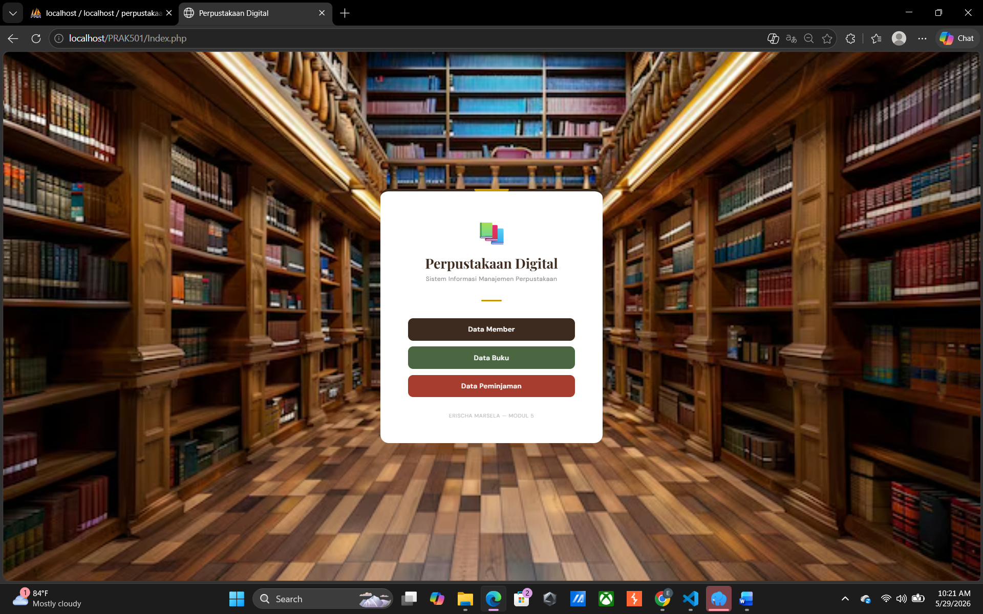
Gambar 2. Dashboard Page
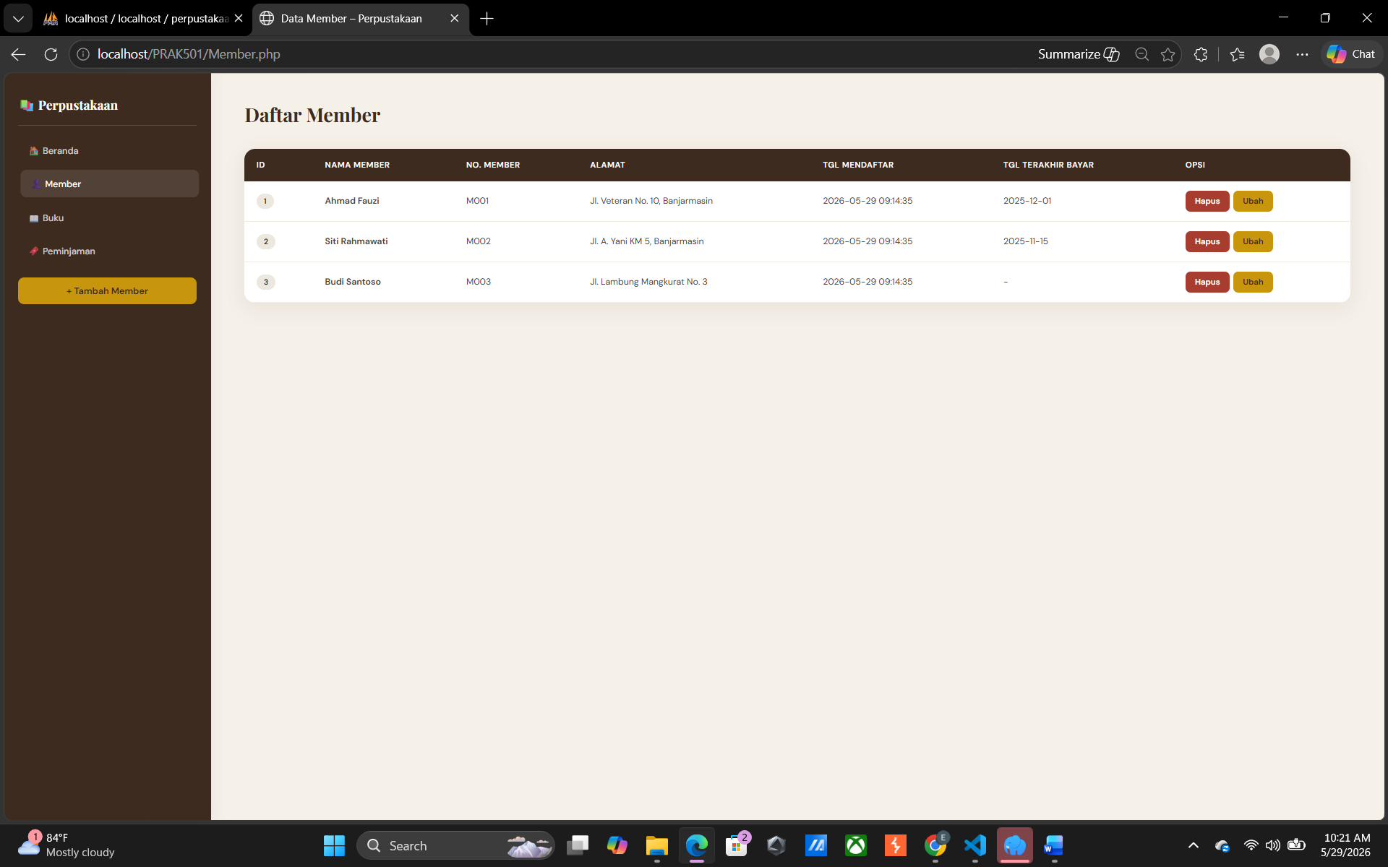
Gambar 3. Daftar Member Page
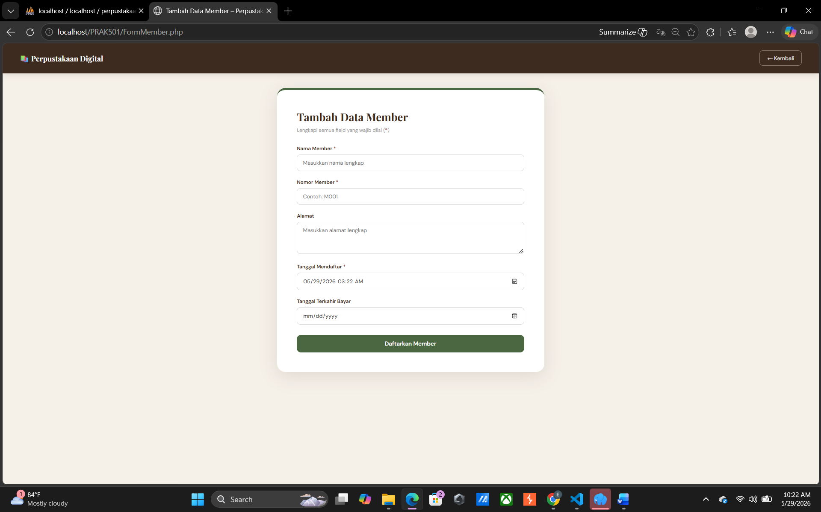
Gambar 4. Form Member Page
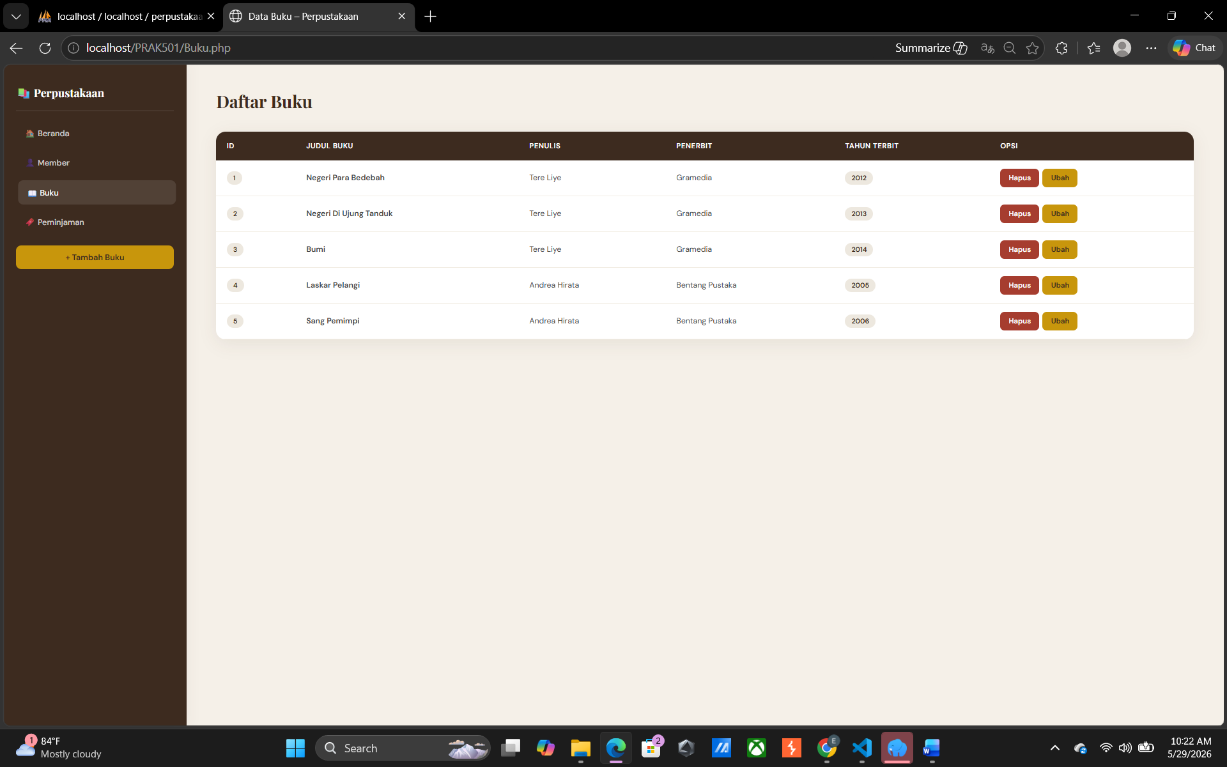
Gambar 5. Daftar Buku Page
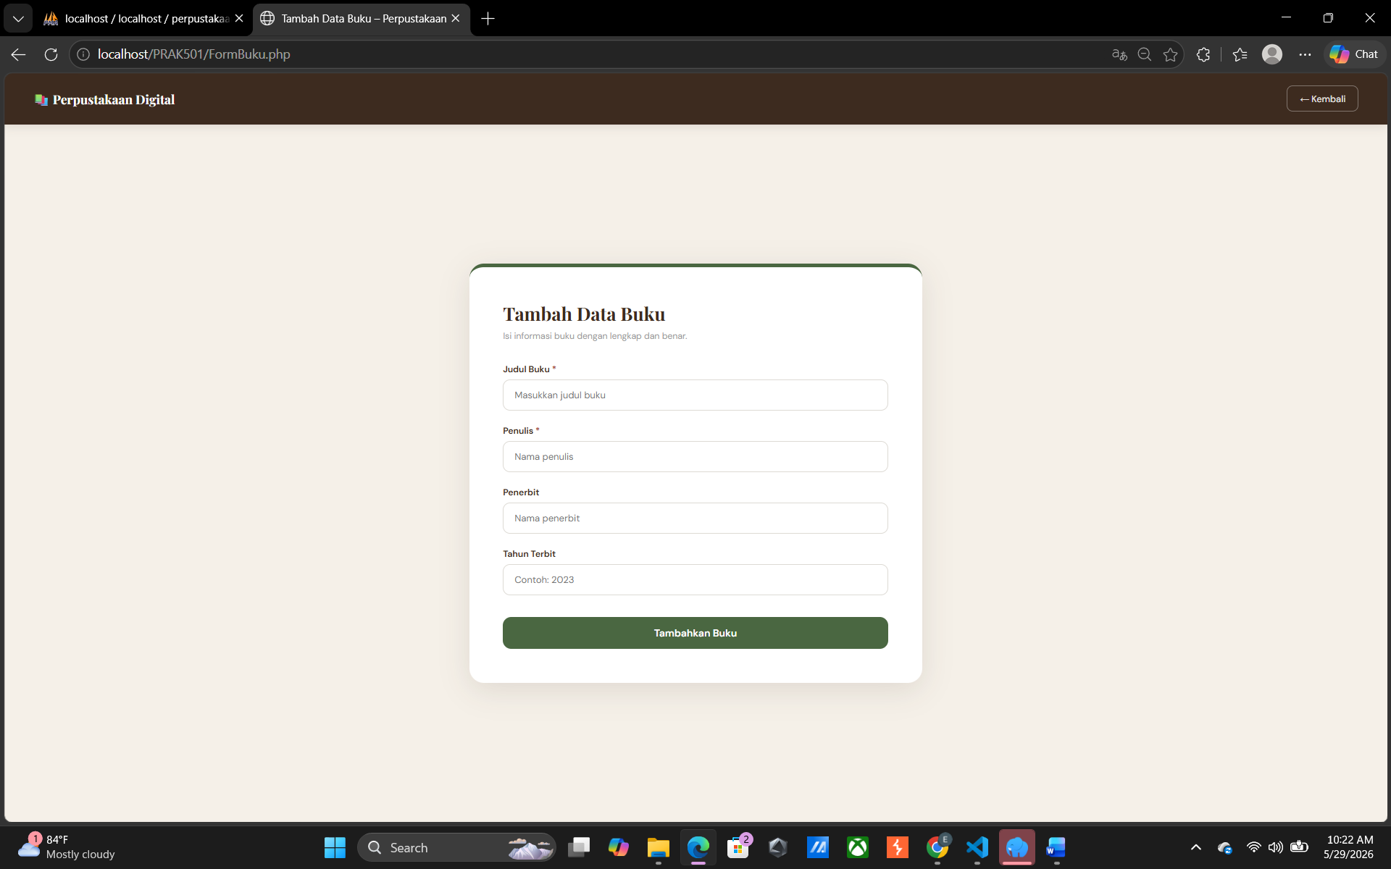
Gambar 6. Form Buku Page
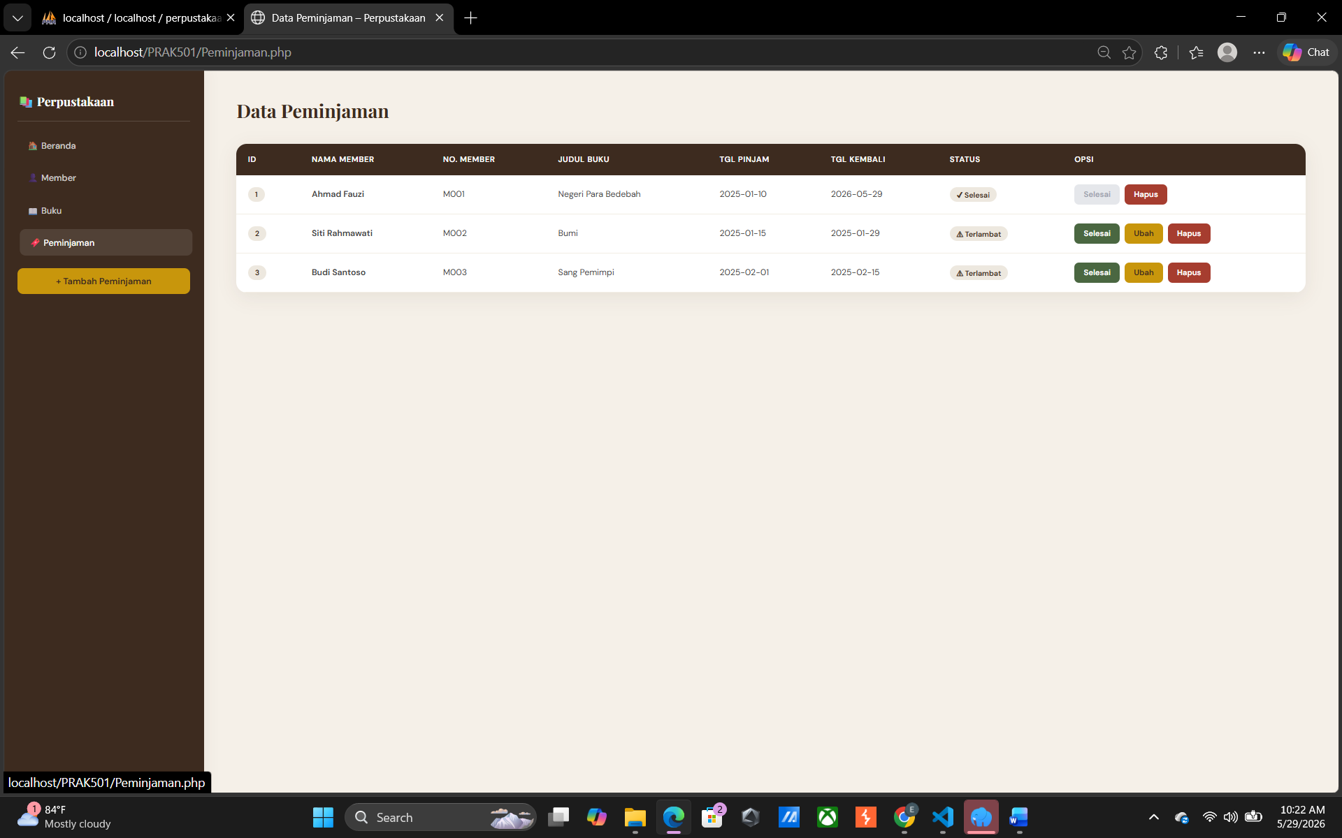
Gambar 7. Data Peminjaman Page
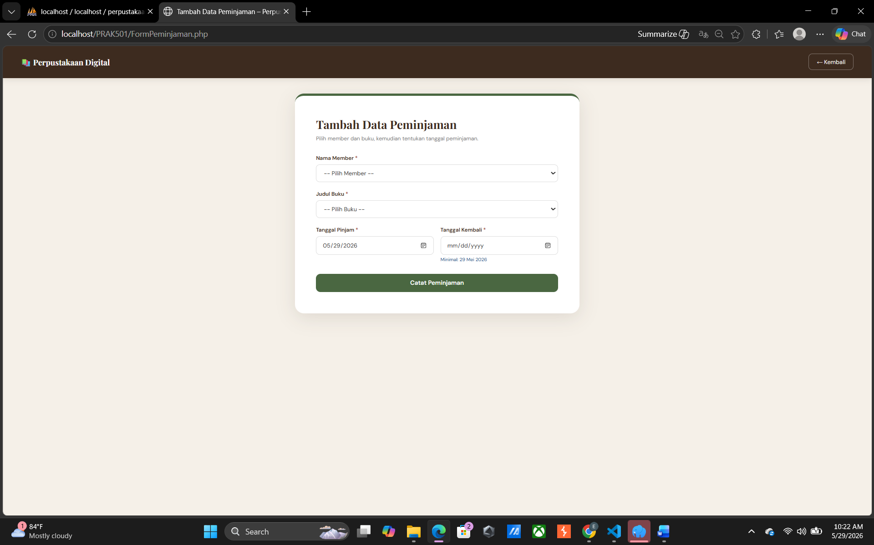
Gambar 8. Form Peminjaman Page

Pembahasan
Koneksi.php mendefinisikan konstanta konfigurasi penting seperti nama host, username, kata sandi, dan nama basis data perpustakaan, sekaligus menyediakan fungsi khusus bernama koneksiDatabase() untuk menghubungkan aplikasi ke MySQL. Koneksi ini kemudian dimanfaatkan oleh berkas Model.php yang bertindak sebagai pusat kendali data, di mana di dalamnya terdapat berbagai fungsi operasional seperti getAllMember(), insertBuku(), hingga deletePeminjaman(). Secara mendetail namun ringkas, setiap fungsi di dalam berkas ini akan menjalankan perintah SQL standar dan secara aman menerapkan fungsi mysqli_real_escape_string untuk mencegah gangguan eror atau serangan injeksi kode saat data dimasukkan ke dalam basis data.
Sementara itu, bagian tampilan atau antarmuka pengguna dikendalikan oleh berkas seperti Index.php, Member.php, Buku.php, Peminjaman.php, serta berkas formulir (Form) terkait. Berkas Index.php berfungsi sebagai halaman utama atau dasbor yang menyajikan menu navigasi untuk mengarahkan pengguna ke pengelolaan data member, buku, atau transaksi peminjaman. Ketika pengguna melakukan sebuah aksi di halaman antarmuka misalnya menekan tombol hapus atau mengisi formulir tambah data halaman tersebut akan menangkap input pengguna, meneruskannya ke fungsi yang tepat di dalam Model.php untuk diproses ke database, dan akhirnya memuat ulang halaman dengan menampilkan pesan notifikasi bahwa operasi telah berhasil dilakukan.

Tautan Git

https://github.com/ERISCHA24/PRAKTIKUMWEB2

